Escape mission 1: The Glowworm Cave

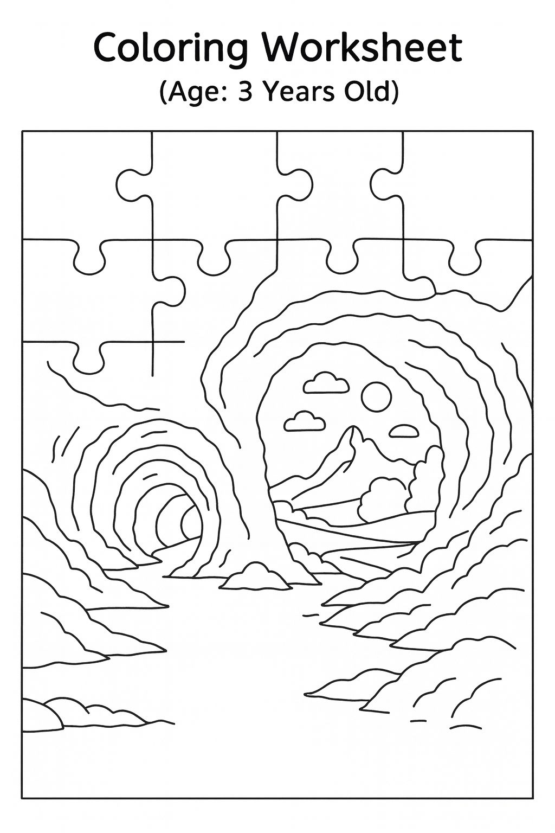Colouring worksheet www.escapemissions.com

Escape mission 1: The Glowworm Cave

Handwriting worksheet

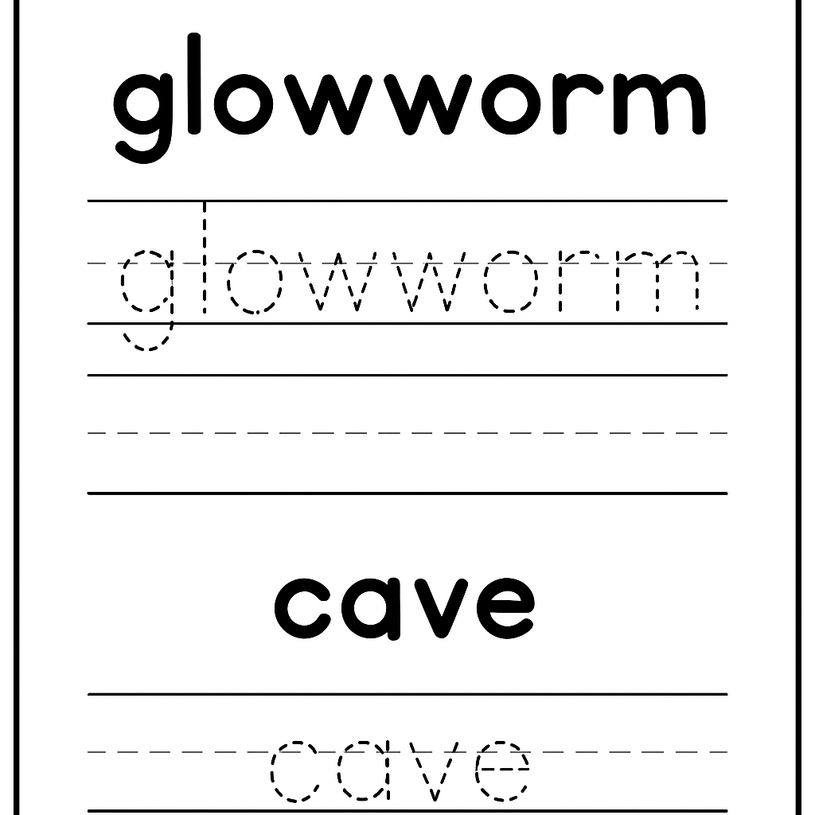



Escape mission 1: The Glowworm Cave

Colouring worksheet

**Keep the Lord’s teachings and commandments with love and faithfulness.**

www.escapemissions.com

Escape mission 1: The Glowworm Cave

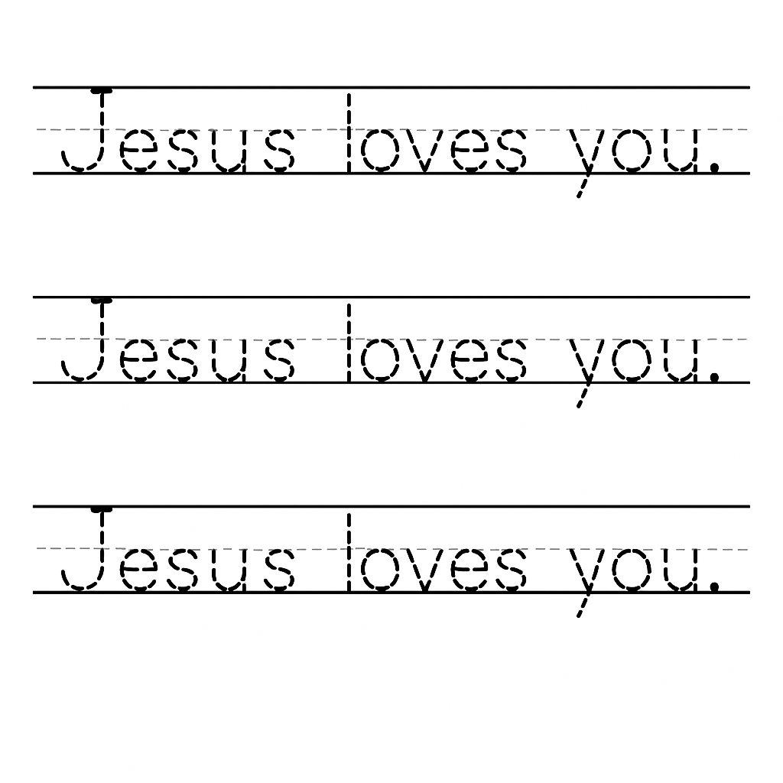Handwriting worksheet

www.escapemissions.com